# **Historical Events: The Trail of Tears**

# **Name:**

*Instructions:* Read the event(s) assigned to your group and answer the questions that follow. Be prepared to share your answers with the class.

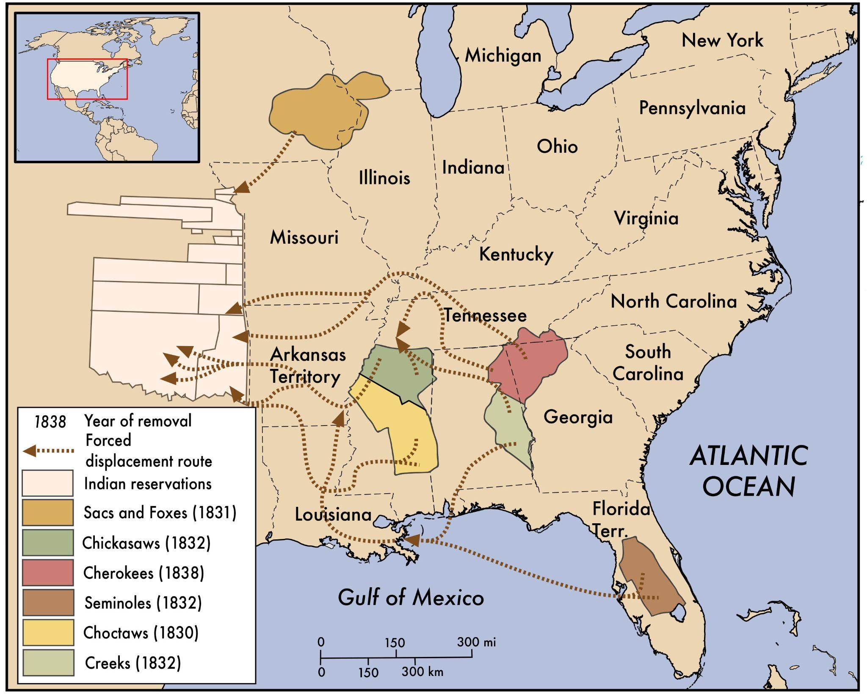

**Note on Disturbing Content**

This reading contains content that may be upsetting for readers. It describes physical and psychological violence, and might be particularly intense for students with a personal connection to the topic. It is important to be sensitive to your classmates and the ways in which this might be a difficult topic to study.

One of the major questions facing the United States in its first century was how it would treat the Native groups in North America. Many early U.S. leaders believed that land ownership was key to preserving liberty and a democratic form of government. With a growing settler population, this would require more and more land. U.S. leaders also believed that white settlers would use the land better than Native peoples and make it more economically productive.

One approach the federal government supported for Native groups was known as assimilation. This policy required Indian groups to adopt white American customs, convert to Christianity, and become small farmers. Even in areas where Indian groups attempted to assimilate, however, they received no protections under U.S. or state laws. Indians were not granted the same rights as white people. Furthermore, in the minds of U.S. leaders, there were limits to assimilation. Most white Americans believed that Indians were racially and culturally inferior and incapable of being part of American society. U.S. leaders ultimately intended for Indian groups to give up their political independence, their land, and their way of life. U.S. leaders were prepared to use violence to force Indian communities that were in or near U.S. states to move to regions west of the Mississippi River.

Between 1830 and 1850, the U.S. government’s actions forced about 100,000 Native people to move west, the majority from communities in Southern states, including the Chickasaws, Chocktaws, Creeks, and Seminoles. Thousands of Native people died during these treks. While some groups moved west with little resistance, some Native groups resisted by refusing to leave their homes. The U.S. government often responded to resistance with military force. For example, in Illinois in 1832, Chief Black Hawk and members of the Sauk and Fox tribes refused to move. In response, President Andrew Jackson sent soldiers who killed hundreds of men, women, and children during the Bad Axe Massacre.

Some Indian groups appealed to the Supreme Court or refused to sign removal treaties with the U.S. government. The Cherokees worked to convince the U.S. government to grant them U.S. citizenship. The government refused, and in 1838 issued an ultimatum: if the Cherokees did not move west immediately, they would be forced to leave. The forced march of the Cherokees became well known as the Trail of Tears, because of the suffering they endured along the way. Escorted by soldiers, they faced inhumane treatment and conditions, including hunger, extreme weather, exhaustion, and violence perpetrated by white soldiers and settlers. Of the fifteen thousand Cherokee people who were forcibly relocated, more than four thousand died from disease, exposure, and malnutrition.

**Questions**

1. Was the “Trail of Tears” a genocide? Give at least two reasons from the text to support your view.

2. What standards from Article II of the Genocide Convention apply to determine if this event was a genocide?

3. What additional information would you like to have about the “Trail of Tears?”